 Approved by PCI New Delhi, Permanently Affiliated to JNTUH

Accredited by NBA (B. Pharmacy) &Accredited by NAAC (A+)

Recognized Under UGC Section 2F & 12B of UGC Act, 1956, by DSIR-SIRO & HI/BI of MSME,

Certified by ISO 9001:2015, AMC of PvPi,

Cheeryal (V), Keesara (M), Medchal-Malkajgiri Dist., Telangana State- 501301

DATE: 05/02/2025

# REPORT ON GUEST LECURE

**Topic of the Event:** Machine Learning Tools for Synergistic Therapeutics: Bridging Herbal Medicine and Modern Drug Discovery

**Date & Time of Event:** February 3rd 2025, 10:30AM

**Hosted by:** Geethanjali College of Pharmacy, Cheeryal, Keesara,Medchal, Telangana.

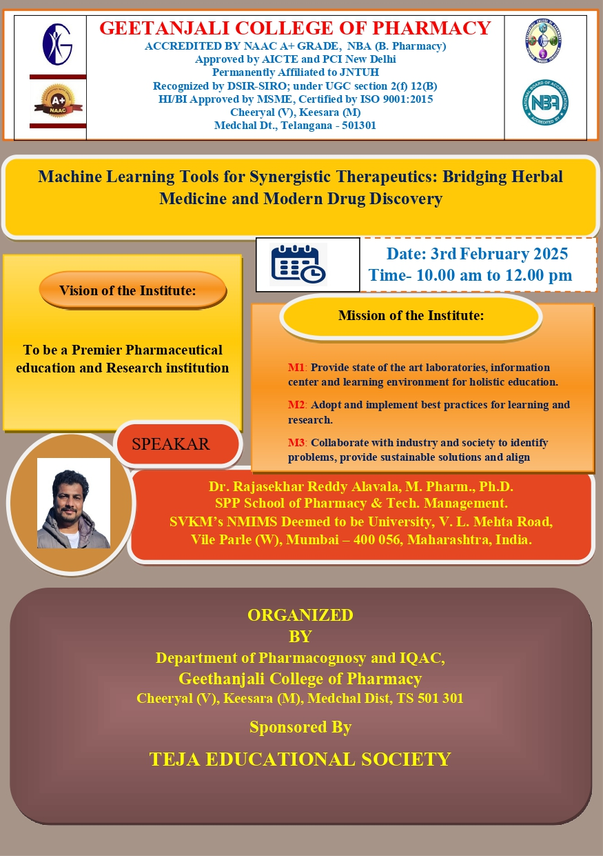

On February 3rd 2025, Geethanjali College of Pharmacy, (Sponsored by Teja Educational Society) organized a guest lecture on the topic“Machine Learning Tools for Synergistic Therapeutics: Bridging Herbal Medicine and Modern Drug Discovery”.

The Guest Speaker for this lecture was Dr. Rajasekhar Reddy Alavala ,M Pharm Ph.D. SPP School of Pharmacy & Tech. Management, SVKM’s NMIMS Deemed to be University, Vile Parle (w), Mumbai. The programme started with welcome address by our Prinicipal Dr.M.Ravi kumar inviting our guest speaker introduced the guest speaker Dr. Rajasekhar Reddy Alavala to the participants which was followed by the session.

In the Session Dr. Rajasekhar Reddy Alavala spoke about the various aspects of Machine learning tools for their synergistic therapeutics by bridging the herbal medicine & drug discovery.

Dr. Rajasekhar Reddy Alavala briefed about

* Lead molecules
* Target identification
* Network pharmacology
* Databases for traditional medicine
* Molecular docking
* Dynamic simulation, etc.

The session was concluded with the questionnaire (Q&A) and the participants clarified their doubts regarding the topic. Around 150 members participated in the session including faculty.

After the Q&A session our Prinicipal Dr.M.Ravi kumar garu felicitated the guest.

Finally the session was ended with vote of thanks

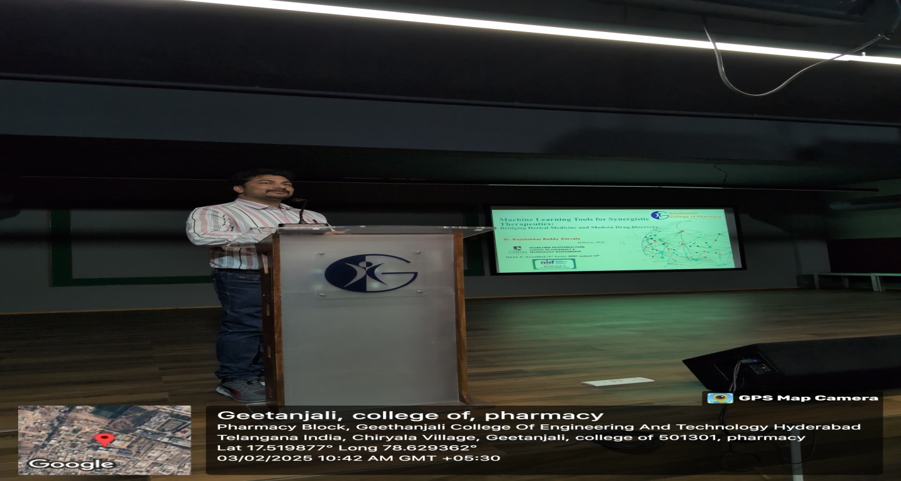

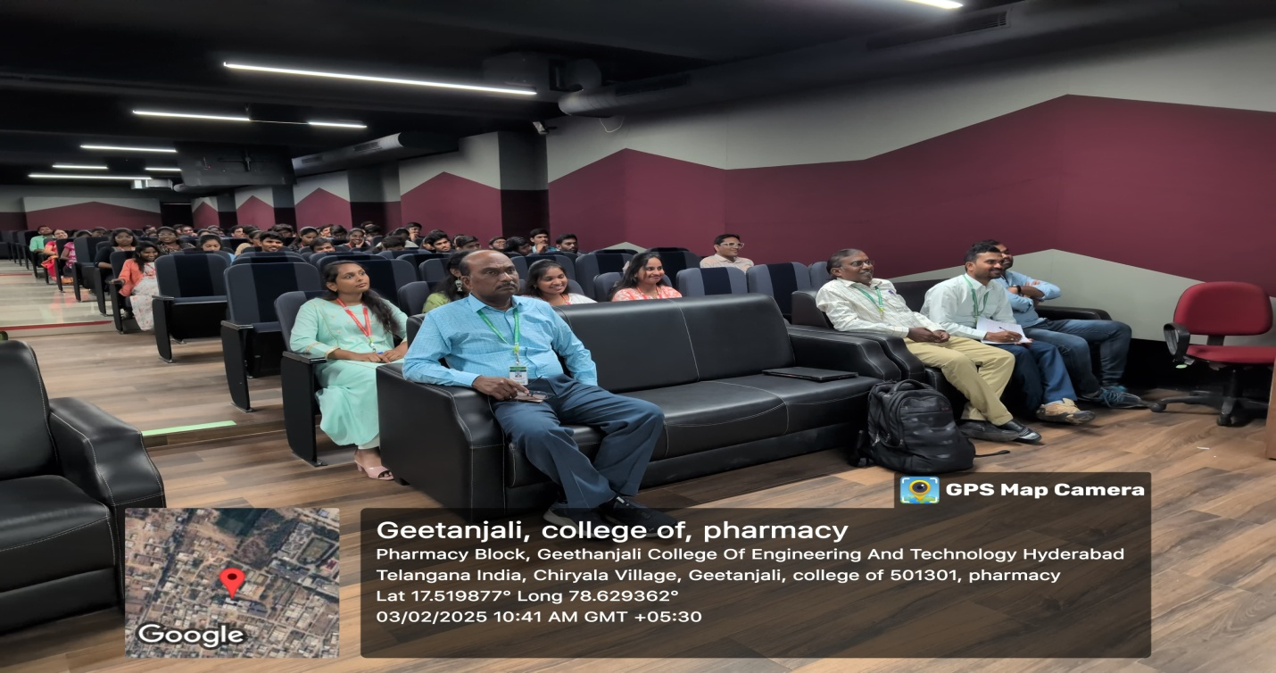

**PRINCIPAL**

 Approved by PCI New Delhi, Permanently Affiliated to JNTUH

Accredited by NBA (B. Pharmacy) &Accredited by NAAC (A+)

Recognized Under UGC Section 2F & 12B of UGC Act, 1956, by DSIR-SIRO & HI/BI of MSME,

Certified by ISO 9001:2015, AMC of PvPi,

Cheeryal (V), Keesara (M), Medchal-Malkajgiri Dist., Telangana State- 501301

DATE: 05/02/2025

# REPORT ON WORKSHOP

**Topic of the Event:** Molecular Docking Hands- on Training

**Date & Time of Event:** February 3rd 2025, 1:00 PM

**Hosted by:** Geethanjali College of Pharmacy, Cheeryal, Keesara,Medchal, Telangana.

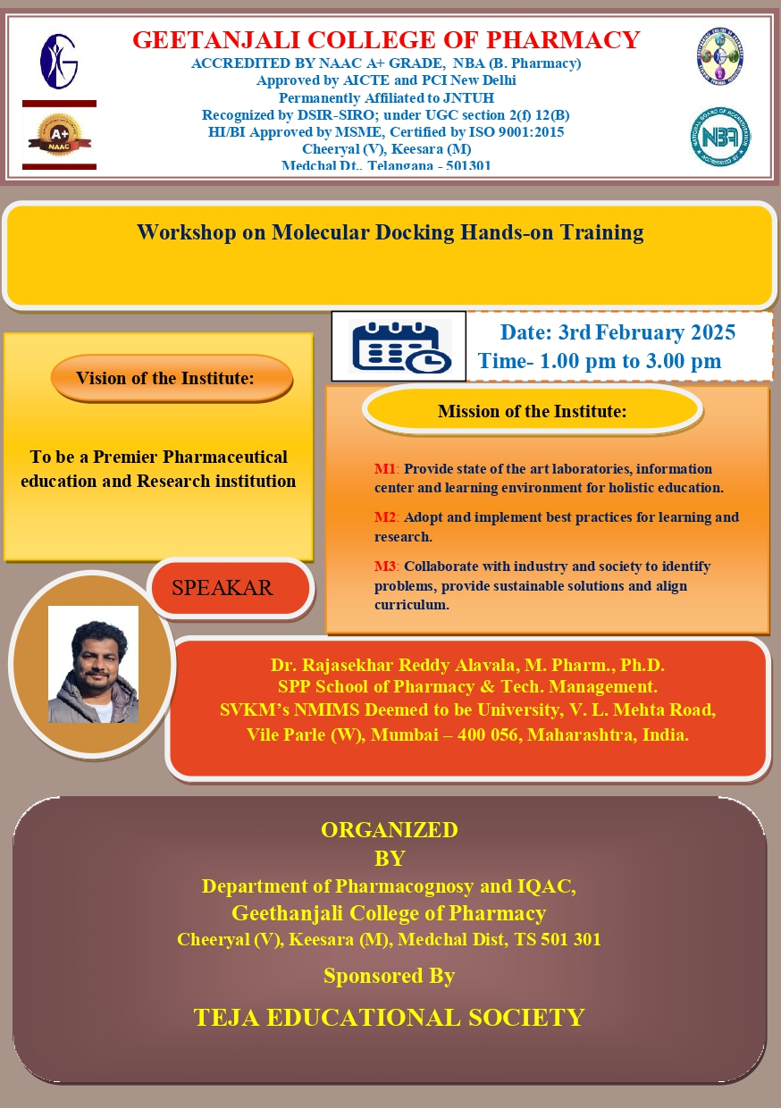

In the Session Dr. Rajasekhar Reddy Alavala spoke about molecular docking hands on training.

Dr. Rajasekhar Reddy Alavala trained about

* Preparation of target protein for docking
* Initialization of lignad for docking
* Preparation of grid map
* Setup docking parameter file
* Running autogrid and autodock
* View docking results
* Suggestions, etc.

The session was concluded with the questionnaire (Q&A) and the participants clarified their doubts regarding the topic. M.Pharmacy students and faculty members attended workshop.

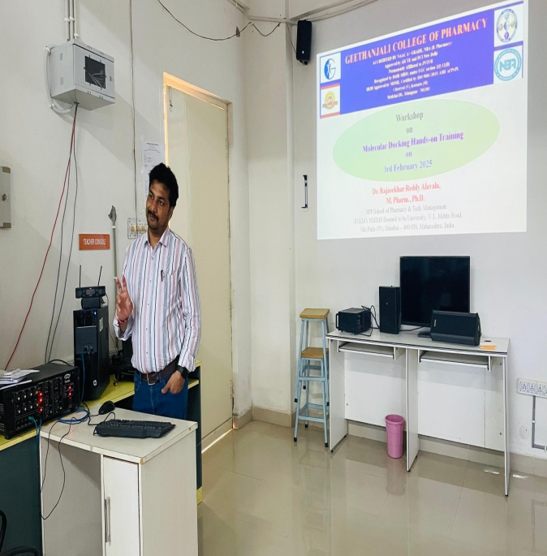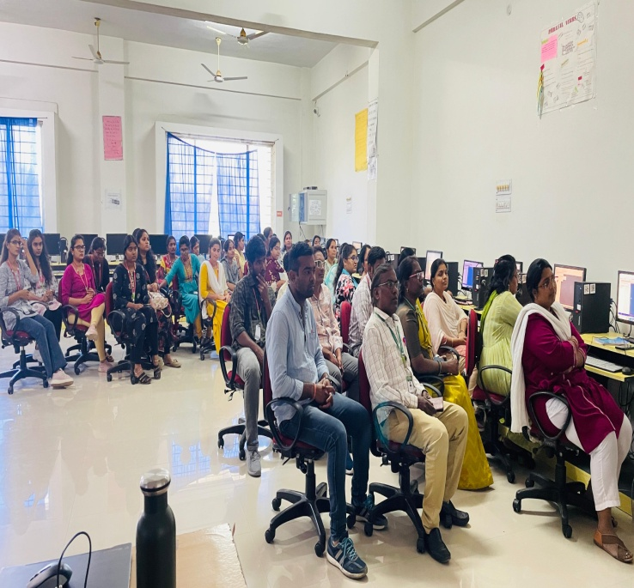

**PRINCIPAL**